SUMMARY OF FORMULAS (MATH30)

- Sample Size (Slovin’s Formula): 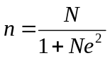
- Range: R = H – L
- Mean (ungrouped data): 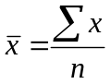
Mean (grouped data): 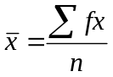 or 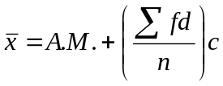
- Median: 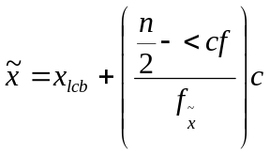
- Mode: 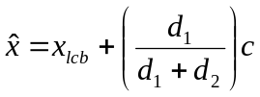
- Quartile: 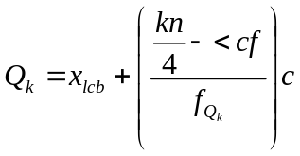
- Decile: 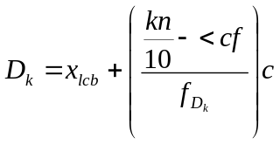
- Percentile: 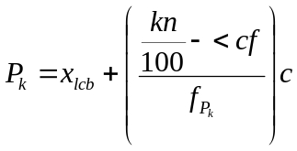
- Mean Deviation (ungrouped): 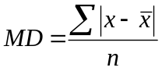
Mean Deviation (grouped): 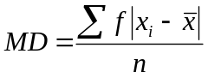
- Variance (ungrouped/sample): 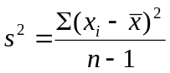
Variance (grouped/population): 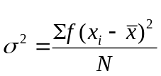
- Standard Deviation (ungrouped/sample): 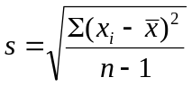
Standard Deviation (grouped/population): 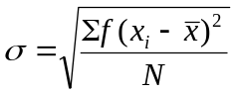
- Interquartile Range: 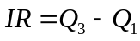
- Quartile Deviation: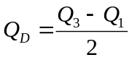
- Coefficient of Variation: CV = 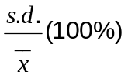
- Kurtosis I.D.: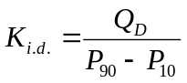
- Kurtosis I.D. (K_{i.d.}):
- Platykurtic, if K_{i.d.} < 0.263
- Mesokurtic, if K_{i.d.} = 0.263
- Leptokurtic, if K_{i.d.} > 0.263

- Kurtosis (ungrouped): 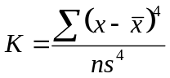
Kurtosis (grouped): 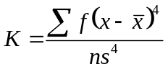

- Kurtosis (K)
- Platykurtic, if K < 3
- Mesokurtic if K = 3
- Leptokurtic if K > 3

- Pearson’s Coefficient of Skewness: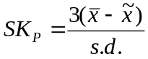
- Skewness (ungrouped): 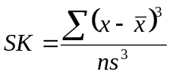
Skewness (grouped): 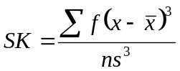

- For SK_{P} and SK,
- if negative, the curve is skewed to the left (negatively skewed)
- if zero, the curve is symmetric
- if positive, the curve is skewed to the right (positively skewed)

- Permutation: _{n}P_{r} 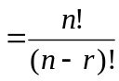
- Permutations with n objects alike: P = 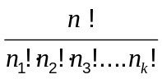
- Circular Permutation: 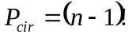

- Circular Permutation (Flipped): 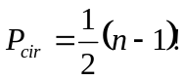

- Combination: _{n}C_{r}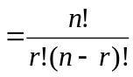
- Standard score: 